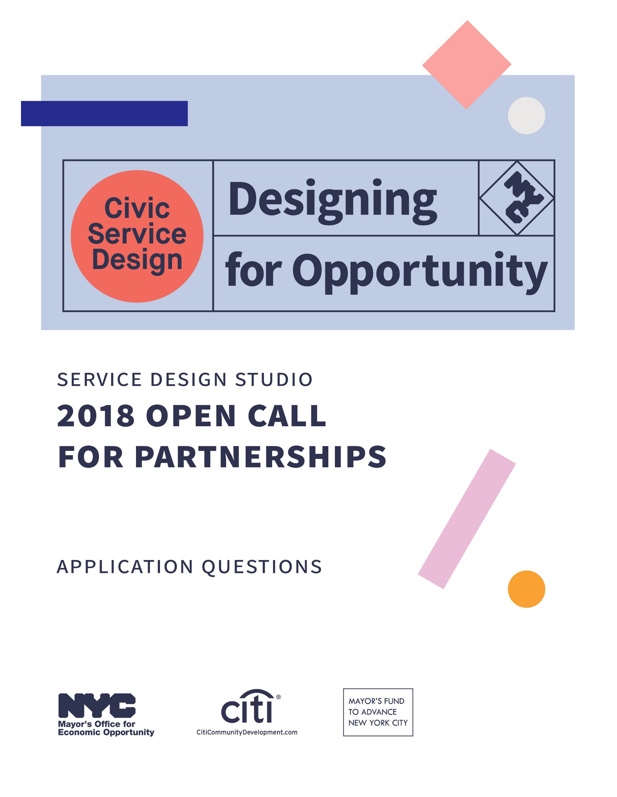

Service Design Studio

2018 Open Call for Partnerships

Application Questions

To apply for Designing for Opportunity, you will need to submit the following online application form. We encourage your team to use this document as a working copy before filling out the online form. The online application form cannot be saved and returned to before submitting.

Application Requirements
Your initiative must:
- Be managed by or contracted through a New York City Government agency or office
- Focus on low-to-moderate income (LMI) New Yorkers
- Begin engagement with the Service Design Studio in early March, 2018
- Engage with the Service Design Studio for 6-12 months
- Involve multiple partners (City agencies, offices and/or nonprofits) in providing a service across a need or population
- Have the ability to provide potential funding and support for implementation, which could include: agency staff, service enhancement(s), policy changes, communications materials, digital products, and change management
- Participate in documenting and sharing their process with a wider audience through articles, case studies, social media and blog posts
- Participate in an independent evaluation of the initiative
Please see the Evaluation Rubric in the Information Packet for full criteria details.
The deadline to submit your final application is 6 pm on February 1, 2018.
Application Questions
Your application is meant to help our Service Design Studio get to know your office, initiative, and team. We are looking for brief responses, but please include as much information as you feel is necessary to answer each question.

Initiative Focus
- In 500 words or less, tell us about your initiative.
- How and why do you think that your initiative and/or agency can benefit from working with the Service Design Studio?
- Which best applies to your initiative? Select one.
- New initiative that has not yet launched
- New initiative that has launched in past few months
- Existing initiative that has launched in past couple of years
- Existing initiative that has been active for several years
- What are the focus area(s) for your initiative? Check all that apply.

- Arts
- Access to Services
- Asset Development
- Business
- Criminal Justice
- Early Childhood
- Education
- Employment
- Finance
- Health
- Housing
- Homelessness
- Public Safety
- Public Space
- Sustainability
- Transportation
- Youth Services
- Veterans Services
- Other
- Who are the primary audiences and partners for your initiative?
  - Think about both the people who use, deliver, and manage the service—including residents, contracted vendors and providers and other government agencies. Please name all partner organizations and offices.
- What research, data and/or precedents exist that support or inspire your initiative?
  - Has something similar been done in another city?
  - Is there research or data that helps you understand how enhancements to your initiative will impact your initiative’s outcomes?

Initiative Outcomes
- How would you define success for your initiative?
  - How does your initiative measure, or plan to measure, outcomes?
  - If your initiative has already launched, tell us about the current framework in place to measure impact and outcomes.
- If possible, please share any existing data on outcomes and impact.
- How many New Yorkers, organizations, and/or businesses is your initiative estimated to reach?
- If applicable, at how many sites is your initiative delivered?
- By working with the Service Design Studio, how would your initiative’s reach and outcomes change?
- What are some current or anticipated barriers to achieving success with your initiative, including challenges to implementing design changes?
Partner Capacity
- How will you assign staff to engage with the Service Design Studio, including the Design Lead?
- How have you engaged your agency leadership with regard to your initiative, and how will you engage them while working with the Service Design Studio?
- What is the budget for the initiative? What are the funding streams?
- What funding streams might be available to support on-going work during and after the engagement with the Service Design Studio, including implementation of enhancements?
- How will you provide access to the people who manage, deliver, and receive the service(s) that your initiative provides? Are there any limitations we should be aware of in interacting with these stakeholders?
- Would you be willing to co-author in-progress social media, blog posts and a final case study on the engagement with the Service Design Studio?
  - Yes
  - No
- Would you be willing to participate in an independent evaluation of the initiative?
  - Yes
  - No
- Do you have any questions for us?

Supporting Materials

Required
Please submit a letter of support from your Commissioner, Office Head, or Deputy Commissioner.

Optional
Please submit additional information including presentations, research studies, data or other materials that may support your application.
If you want to submit more than one document, please package them all in to a single ZIP file no larger than 3 MB.

http://on.nyc.gov/opencallapplication
The Service Design Studio utilizes the following definition for low-to-moderate income (LMI): individuals earning $58,953 or below, which is less than 80% of the New York-Jersey City-White Plains, NY-NJ Metropolitan Statistical Area’s (MSA code 35614) Federal Financial Institutions Examination Council (FFIEC)-estimated 2017 Median Family Income of $73,700.
http://on.nyc.gov/opencallinfo

